**# Entity Relationship Diagram**

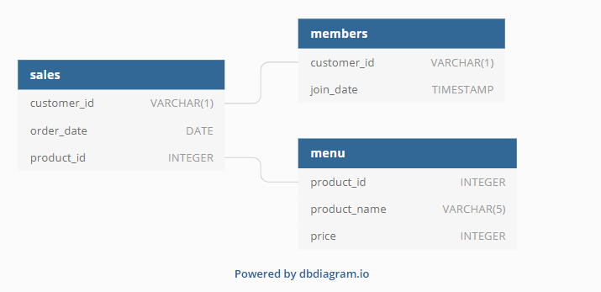

**# Question**

**# Q1. What is the total amount each customer spent at the restaurant?**

SELECT

    s.customer_id,

    sum(m.price) as total_sale

FROM sales s

    INNER JOIN menu m ON s.product_id = m.product_id

GROUP BY s.customer_id

ORDER BY s.customer_id ASC;

**# Q2. How many days has each customer visited the restaurant?**

SELECT

    s.customer_id,

    COUNT(DISTINCT s.order_date) AS visit_count

FROM sales s

GROUP BY s.customer_id;

**# Q3. What was the first item from the menu purchased by each customer?**

WITH ordered_sales AS (

  SELECT

    s.customer_id,

    s.order_date,

    m.product_name,

    DENSE_RANK() OVER (

      PARTITION BY s.customer_id

      ORDER BY s.order_date) AS rank

  FROM sales s

    INNER JOIN menu m

        ON s.product_id = m.product_id

)

SELECT

  customer_id,

  product_name

FROM ordered_sales

WHERE rank = 1

GROUP BY customer_id, product_name;

**# Q4. What is the most purchased item on the menu and how many times was it purchased by all customers?**

SELECT

    m.product_id,

    m.product_name,

    COUNT(s.product_id) AS number_of_purchases

FROM menu m

    INNER JOIN sales s

        ON m.product_id = s.product_id

GROUP BY m.product_id

ORDER BY number_of_purchases DESC

LIMIT 1;

**# Q5. Which item was the most popular for each customer?**

WITH ordered_sales AS (

  SELECT

    s.customer_id,

    s.order_date,

    m.product_name,

    DENSE_RANK() OVER (

      PARTITION BY s.customer_id

      ORDER BY s.order_date) AS rank

  FROM sales s

  INNER JOIN menu m

    ON s.product_id = m.product_id

)

SELECT

  customer_id,

  product_name

FROM ordered_sales

WHERE rank = 1

GROUP BY customer_id, product_name;

**# Q6. Which item was purchased first by the customer after they became a member?**

WITH joined_as_member AS (

  SELECT

    m.customer_id,

    s.product_id,

    ROW_NUMBER() OVER (

      PARTITION BY m.customer_id

      ORDER BY s.order_date) AS row_num

  FROM members m

  INNER JOIN sales s

    ON m.customer_id = s.customer_id

    AND s.order_date >= m.join_date

)

SELECT

  customer_id,

  product_name

FROM joined_as_member j

    INNER JOIN menu m

        ON j.product_id = m.product_id

WHERE row_num = 1

ORDER BY customer_id ASC;

**# Q7. Which item was purchased just before the customer became a member?**

WITH purchased_prior_member AS (

  SELECT

    m.customer_id,

    s.product_id,

    ROW_NUMBER() OVER (

      PARTITION BY m.customer_id

      ORDER BY s.order_date DESC) AS rank

  FROM members m

    INNER JOIN sales s

        ON m.customer_id = s.customer_id

        AND s.order_date < m.join_date

)

SELECT

  p.customer_id,

  m.product_name

FROM purchased_prior_member p

    INNER JOIN menu m

        ON p.product_id = m.product_id

WHERE rank = 1

ORDER BY p.customer_id ASC;

**# Q8. What is the total items and amount spent for each member before they became a member?**

SELECT

  s.customer_id,

  COUNT(s.product_id) AS total_items,

  SUM(mn.price) AS total_sales

FROM sales s

    INNER JOIN members m

        ON s.customer_id = m.customer_id

        AND s.order_date < m.join_date

    INNER JOIN menu mn

        ON s.product_id = mn.product_id

GROUP BY s.customer_id

ORDER BY s.customer_id;

**# Q9. If each $1 spent equates to 10 points and sushi has a 2x points multiplier — how many points would each customer have?**

WITH points_cte AS (

  SELECT

    product_id,

    CASE

      WHEN product_id = 1 THEN price * 20

      ELSE price * 10 END AS points

  FROM menu

)

SELECT

  sales.customer_id,

  SUM(p_cte.points) AS total_points

FROM sales s

    INNER JOIN points_cte p_cte

        ON s.product_id = p_cte.product_id

GROUP BY s.customer_id

ORDER BY s.customer_id;

**# Q10: In the first week after a customer joins the program (including their join date) they earn 2x points on all items, not just sushi — how many points do customer A and B have at the end of January?**

WITH dates_cte AS (

  SELECT

    customer_id,

      join_date,

      join_date + 6 AS valid_date,

      DATE_TRUNC(

        'month', '2021-01-31'::DATE)

        + interval '1 month'

        - interval '1 day' AS last_date

  FROM members

)

SELECT

  sales.customer_id,

  SUM(CASE

    WHEN mn.product_name = 'sushi'

        THEN 2 * 10 * mn.price

    WHEN s.order_date BETWEEN d.join_date AND d.valid_date

        THEN 2 * 10 * mn.price

    ELSE 10 * mn.price END) AS points

FROM sales s

    INNER JOIN dates_cte d

        ON s.customer_id = d.customer_id

        AND d.join_date <= s.order_date

        AND s.order_date <= d.last_date

    INNER JOIN menu mn

        ON s.product_id = mn.product_id

GROUP BY sales.customer_id;